**Name:** Waleed Amjad

**Roll No:** 2023-BS-Ai-054

**Department:** AI

**Sec:** A

**Semester:** 3rd

***Home Assignment***



**Program 1(Array basic)**

**Code:**

#include <iostream>

using namespace std;

int main() {

int arr[5] = {10, 20, 30, 40, 50};

cout << "First element: " << arr[0] << endl;

cout << "Fourth element: " << arr[3] << endl;

return 0;

}

**Output:**

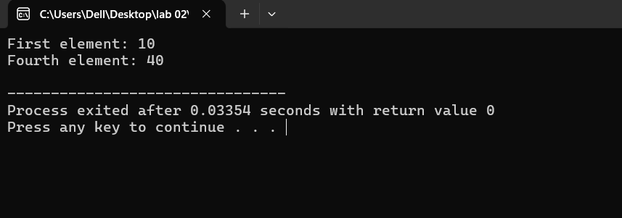

**Program 2(Sum and Sub)**

**Code:**

#include <iostream>

using namespace std;

int main() {

int arr[5] = {10, 20, 30, 40, 50};

int sum = 0;

int sub=0;

for(int i = 0; i < 5; i++) {

sum += arr[i];

}

for(int i=0;i<5;i++){

sub-=arr[i];

}

cout << "Sum of array elements: " << sum << endl;

cout<<"The Diff of array elements: "<< sub<<endl;

return 0;

}

**Output:**

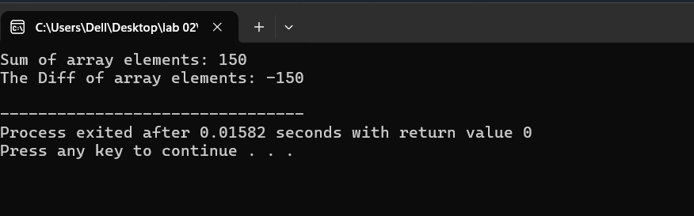

**Program 3(Maximum and Minimum)**

**Code:**

#include <iostream>

using namespace std;

int main() {

int arr[5] = {10, 25, 15, 5, 20};

int max = arr[0];

int min = arr[0];

for(int i = 1; i < 5; i++) {

if(arr[i] > max) {

max = arr[i];

}

}

for(int i = 1; i < 5; i++) {

if(arr[i] < min) {

min = arr[i];

}

}

cout << "Maximum value: " << max << endl;

cout << "Minimum value: " << min << endl;

return 0;

}

**Output:**

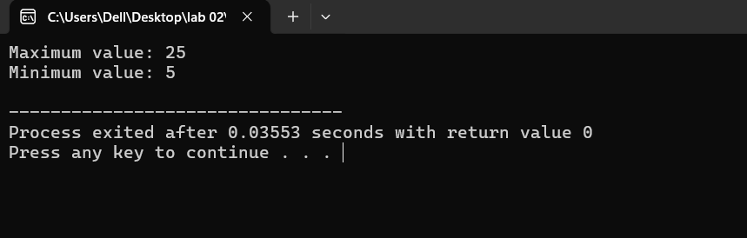

**Program 4(Average)**

**Code:**

#include <iostream>

using namespace std;

int main() {

int arr[5] = {10, 20, 30, 40, 50};

int sum = 0;

for(int i = 0; i < 5; i++) {

sum += arr[i];

}

float average = sum/5;

cout << "Average value: " << average << endl;

return 0;

}

**Output:**

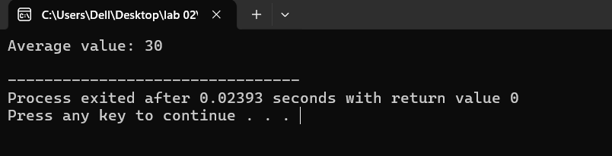

**Program 5(Reverse of Array)**

**Code:**

#include <iostream>

using namespace std;

int main() {

int n;

cout<<"Enter the size of array: "<<endl;

cin>>n;

int arr[n];

cout<<"\nEnter the elements of array: "<<endl;

for(int i=0;i<n;i++){

cin>>arr[i];

}

cout << "\nReversed array: ";

for(int i = n-1; i >= 0; i--) {

cout << arr[i] << " ";

}

return 0;

}

**Output:**

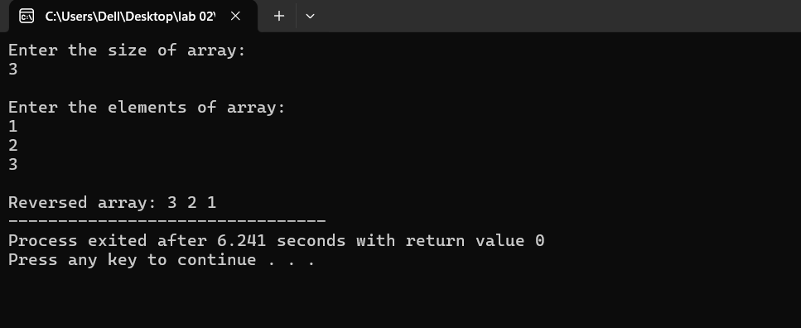

**Program 6(Prime number)**

**Code:**

#include <iostream>

using namespace std;

int main()

{

int n;

cout<<"Enter the size of array: "<<endl;

cin>>n;

int arr[n];

cout<<"Enter the elements of array: "<<endl;

for(int i;i<n;i++){

cin>>arr[i];

}

cout<<"\nThe prime numbers in array are: "<<endl;

for(int i;i<n;i++){

if(arr[i]>1){

int j;

for( j=2;j<arr[i];j++){

if (arr[i]%j==0){

cout<<"No prime number!"<<endl;

break;

}

}

if(j==arr[i]){

cout<<arr[i]<<"\n";

}

}

}

cout<<endl;

return 0;

}

**Output:**

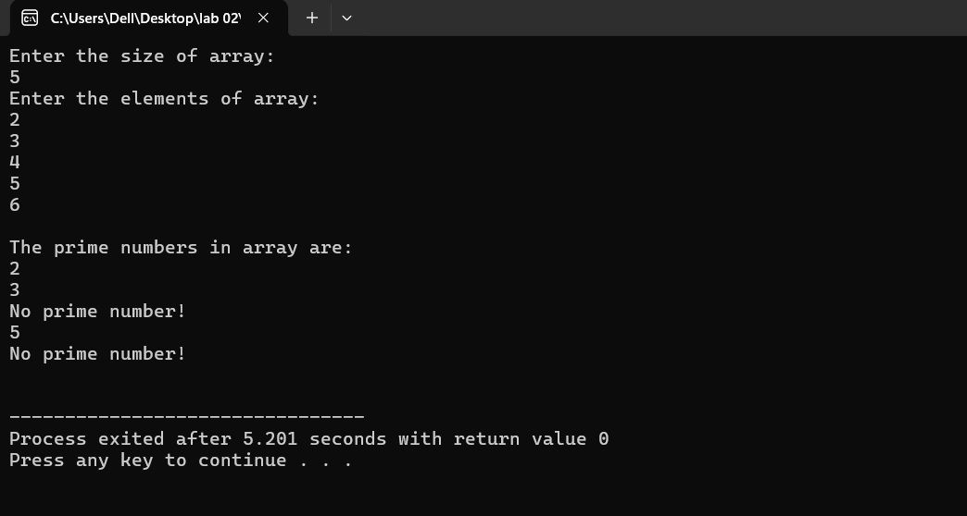

***End of Assignment***

***------------------------------------------------------------***